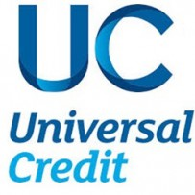
Information Pack

CONTENTS

What is Universal Credit? 3

What you can do to prepare 5

Your Universal Credit journey 6

Universal Credit roll out 7

Checklist 8

What is Universal Credit?
- Universal Credit is a new benefit for working age people designed to support people who have a low (or no) income with their basic living expenses and housing costs.

- Universal Credit replaces the following benefits:

  - Housing Benefit;
  - Child Tax Credit;
  - Income Support;
  - Working Tax Credit;
  - Income-based Jobseeker’s Allowance; and
  - Income-related Employment and Support Allowance.

Other benefits will continue to be paid separately such as Disability Living Allowance, Personal Independence Payment and Carer's Allowance. Child Benefit will also continue to be paid separately.

Benefits based on National Insurance contributions, such as contribution-based Jobseeker’s Allowance and contributory Employment and Support Allowance, will not be replaced and will work alongside Universal Credit.

- Universal Credit is paid in arrears on the same date each month. If you live with someone as a couple and you are both entitled to claim Universal Credit, you will get one monthly joint payment paid into a single bank account.

- Although Universal Credit is made up of different elements it is paid to you as one amount. This means the money to help with your housing costs is usually paid direct to you and not to the Association, so you will be responsible for ensuring your rent is paid.
- It usually takes 5 weeks for your claim to be assessed and your first payment to arrive. This is made up of a one month assessment period and up to 7 days for the payment to reach your account. You will continue to receive Housing Benefit for 2 weeks after making your claim.

- If you don’t have enough to live on while you wait for your first payment or have a change in circumstances, you may be able to get a Universal Credit advance payment. You will normally be notified of the decision the same day you apply. The advance payment is a loan - you’ll have to pay it back, but you won’t pay any interest. The repayments will be automatically deducted from your Universal Credit payments over a 12 month period.

What you can do to prepare!

Step 1 – Rent Account
Ensure that your rent account is clear and at least a month in advance in line with your Tenancy Agreement. It is strongly advisable to start making payments now in preparation for the switch over. The delay in Universal Credit payments will not change the requirement that rent needs to be paid in full and on time.

Step 2 – Internet Access
Universal Credit Full Service is an internet online system only. It is important you have internet access in order to manage your claim. You must still phone the jobcentre to book an appointment for ID verification, if this cannot be done online, and to arrange a work coach interview. You will need to provide a mobile phone number and email address as these are required for your claim.

Step 3 – Bank Account
Universal Credit is paid once a month, into your bank, building society or credit union account. If you do not have one of these accounts you will need to set one up to make and receive your payments.

Step 4 – Budgeting
As Universal Credit will be paid in one single payment it will be helpful to draw up a monthly budget. Go to www.moneyadviceservice.org.uk to complete your own budget planner or contact the office on 01790 754219 if you would like assistance.
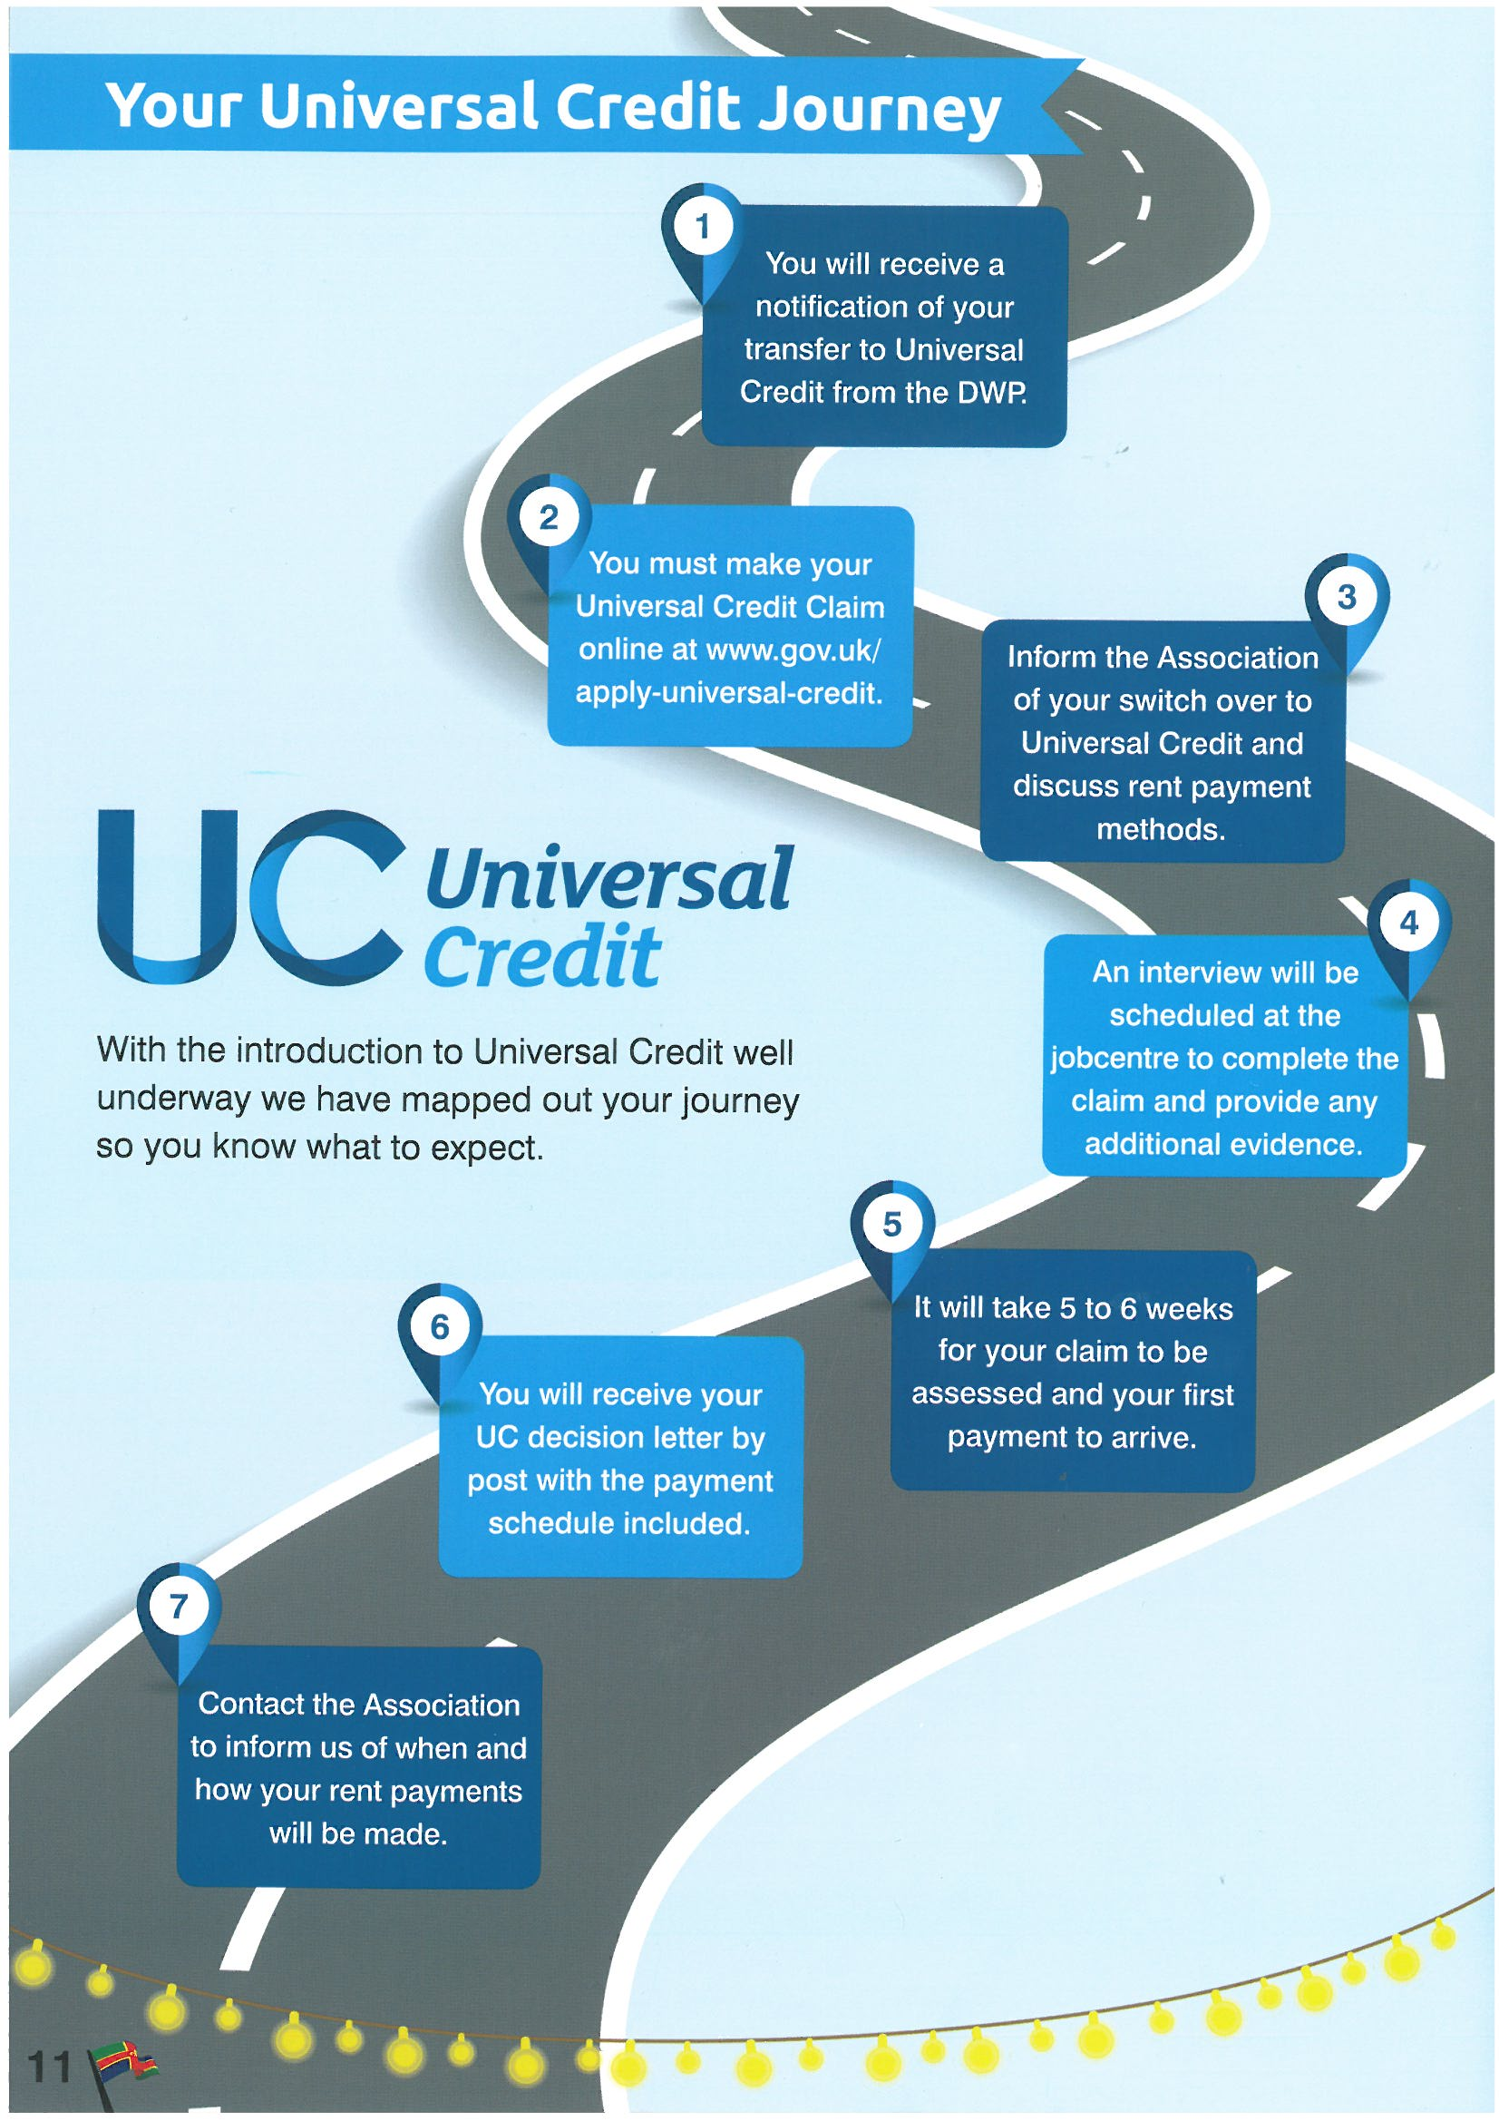
Universal Credit Roll Out

Stage 1
2015-2016
Universal Credit gradually rolled out across the whole of Great Britain for new claims by single jobseekers, completing on 27 April 2016. All new benefit claims by single jobseekers will now be for Universal Credit not existing benefits and tax credits.
Stage 2
2017-2018
By September 2018 new claims by all groups will be for Universal Credit not existing benefits and tax credits. This includes existing claimants who have a change in circumstances.
Stage 3
July 2019 onwards
All existing benefit and tax credit claimants who do not have a change of circumstance will then be migrated onto Universal Credit. You will be informed by the Department of Work and Pensions when this change is due to take place.
Checklist
